Installing TomEE using the drop-in .war approach
If you prefer, TomEE can be setup by deploying a .war file into an existing Tomcat 7.x installation, as opposed to using the all-in-one bundle. This guide provides a set of step-by-step instructions to this approach. Please note that TomEE 1.7.x does not recommend Tomcat versions less than 7.0.54. Tomcat 8 is not currently supported in the released version, but you can check out the developer branch to see progress here.
- Download the Apache Tomcat 7.0.55 server. http://tomcat.apache.org/download-70.cgi
- Unzip the Tomcat distribution file.
- Update $CATALINA_HOME/conf/tomcat-users.xml to add a tomee user to allow access to the installer page.
- <!-- Activate/create these lines to get access to TomEE GUI -->
- <role rolename="tomee-admin" />
<user username="tomee" password="tomee" roles="tomee-admin" />
- Download the .war file you wish to use - either the tomee-webapp-1.7.1.war (for the webprofile installation) or tomee-webapp-plus-1.7.1.war (for the plus version).
- Copy and rename the .war file to $CATALINA_HOME/webapps/tomee.war (the .war filename is important).
- Start Tomcat.
- Go to the TomEE installer webapp (http://localhost:8080/tomee/) and login with the user you added to tomcat-users.xml.
- Verify the values and click "Confirm".
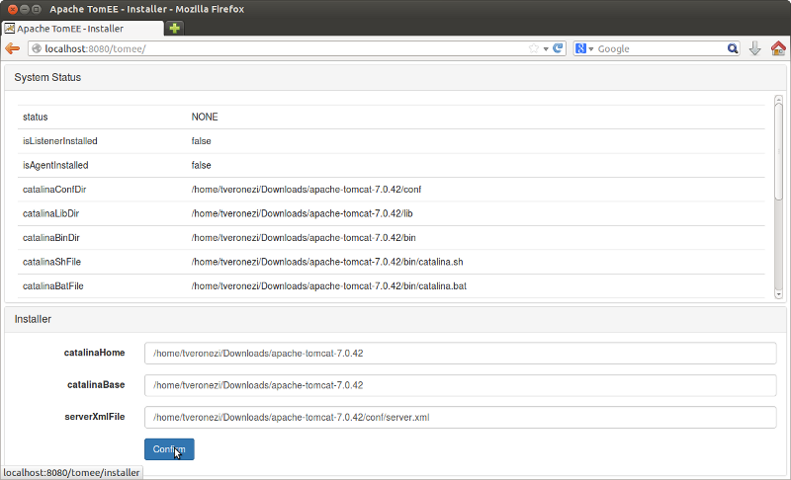
- Restart Tomcat.
- Your TomEE installation is now complete!

Configuraing TomEE to use External ActiveMQ
- Add the ActiveMQ libraries from the OpenEJB standalone project to the [TomEE]/lib directory. These libraries are also included in the subdirectory, activemq_lib_list. Minimally, the following jars are needed:
  - activemq-broker-5.10.2.jar
  - activemq-client-5.10.2.jar
  - activemq-ra-5.10.2.jar
  - geronimo-connector-3.1.1.jar
  - jconn3.jar

- Modify [TomEE]\conf\openejb.xml by adding the following database resources. An example openejb.xml can be found in the root directory. For some reason, there exist a problem when configuring datasources in Tomcat’s context.xml.
<Resource id = "jdbc/accounting" type="DataSource">
JdbcDriver com.sybase.jdbc3.jdbc.SybDriver
JdbcUrl jdbc:sybase:Tds:localhost:2638?ServiceName=accounting
UserName dba
Password sql
JtaManaged true
</Resource>

<Resource id = "jdbc/projecttracker" type="DataSource">
JdbcDriver com.sybase.jdbc3.jdbc.SybDriver
JdbcUrl jdbc:sybase:Tds:localhost:2638?ServiceName=projecttracker
UserName dba
Password sql
JtaManaged true
</Resource>

<Resource id = "jdbc/authentication" type="DataSource">
JdbcDriver com.sybase.jdbc3.jdbc.SybDriver
JdbcUrl jdbc:sybase:Tds:localhost:2638?ServiceName=authentication
UserName dba
Password sql
JtaManaged true
</Resource>

<Resource id = "jdbc/addressbook" type="DataSource">
JdbcDriver com.sybase.jdbc3.jdbc.SybDriver
JdbcUrl jdbc:sybase:Tds:localhost:2638?ServiceName=contacts
UserName dba
Password sql
JtaManaged true
</Resource>

<Resource id = "jdbc/mime" type="DataSource">
JdbcDriver com.sybase.jdbc3.jdbc.SybDriver
JdbcUrl jdbc:sybase:Tds:localhost:2638?ServiceName=mime
UserName dba
Password sql
JtaManaged true
</Resource>

- Modify [TomEE]\conf\openejb.xml by adding the following ActiveMQ configuration:
<Resource id="MyJmsResourceAdapter" type="ActiveMQResourceAdapter">
# Do not start the embedded ActiveMQ broker
BrokerXmlConfig =
ServerUrl = tcp://localhost:61616
</Resource>

<Resource id="MyJmsConnectionFactory" type="javax.jms.ConnectionFactory">
ResourceAdapter = MyJmsResourceAdapter
</Resource>

<Container id="MyJmsMdbContainer" ctype="MESSAGE">
ResourceAdapter = MyJmsResourceAdapter
</Container>
- Add jconn3.jar to [TomEE]\lib.
- Create \apps directory under [TomEE]. This is where the EJB deployment jars will be placed.
- Restart Tomcat.

